**Virtual Local Area Network (VLAN)**

**Intended Learning Outcome:**a. To understand the properties of VLAN.  
b. To analyze how VLAN is used for forwarding the packets within one single physical Switch.

**Expected skills:**The basic concepts of LAN, Switch, IP address and Subnet mask.   
  
**Tools Required:**Cisco Packet Tracer Simulation Software  
  
**Session Detail:**

A VLAN is a group of end stations with a common set of requirements, independent of physical location. VLANs have the same attributes as a physical LAN but allow you to group end stations even if they are not located physically on the same LAN segment.

VLANs are usually associated with IP sub networks. For example, all the end stations in a particular IP subnet belong to the same VLAN. Traffic between VLANs must be routed. LAN port VLAN membership is assigned manually on a port-by-port basis.

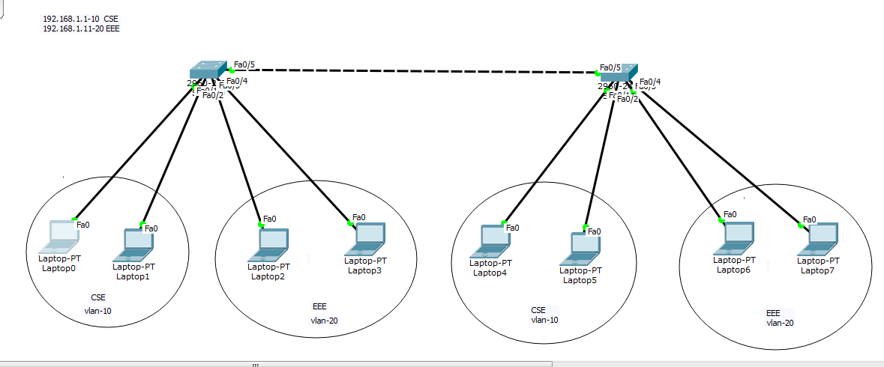

**Figure: VLAN Configuration**

At first give IP the entire host for CSE and EEE .CSE can access only CSE but not EEE,same for EEE.

**Give IP address as I given:**

**CSE SW1:**

Laptop0:192.168.1.2

Laptop1:192.168.1.3

**EEE SW1**

Laptop2:192.168.1.11

Laptop3:192.168.1.12

**CSE SW2**

Laptop4:192.168.1.4

Laptop5:192.168.1.5

**EEE SW2**

Laptop6:192.168.1.13

Laptop7:192.168.1.14

**First Switch Configuration:**

**Switch>**

**Switch>en**

**Switch#configure terminal**

**Enter configuration commands, one per line. End with CNTL/Z.**

**Switch(config)#vlan 10**

**Switch(config-vlan)#name CSE**

**Switch(config-vlan)#exit**

**Switch(config)#vlan 20**

**Switch(config-vlan)#name EEE**

**Switch(config-vlan)#exit**

**Switch(config)#exit**

**Switch(config)#interface fastEthernet 0/1**

**Switch(config-if)#switchport access vlan 10**

**Switch(config-if)#exit**

**Switch(config)#interface fastEthernet 0/2**

**Switch(config-if)#switchport access vlan 10**

**Switch(config-if)#exit**

**Switch(config)#interface fastEthernet 0/3**

**Switch(config-if)#switchport access vlan 20**

**Switch(config-if)#exit**

**Switch(config)#interface fastEthernet 0/4**

**Switch(config-if)#switchport access vlan 20**

**Switch(config-if)#exit**

**Switch(config)#exit**

**Switch(config)#interface fastEthernet 0/5**

**Switch(config-if)#switchport mode trunk**

**Switch(config-if)#**

**%LINEPROTO-5-UPDOWN: Line protocol on Interface FastEthernet0/5, changed state to down**

**%LINEPROTO-5-UPDOWN: Line protocol on Interface FastEthernet0/5, changed state to up**

**Switch(config-if)#exit**

**Switch(config)#interface range fastEthernet 0/1 -4**

**Switch(config-if-range)#switchport mode access**

**Switch(config-if-range)#exit**

**Switch(config)#**

**Second Switch Configuration:**

**Switch>**

**Switch>en**

**Switch#configure terminal**

**Enter configuration commands, one per line. End with CNTL/Z.**

**Switch(config)#vlan 10**

**Switch(config-vlan)#name CSE**

**Switch(config-vlan)#exit**

**Switch(config)#vlan 20**

**Switch(config-vlan)#name EEE**

**Switch(config-vlan)#exit**

**Switch(config)#exit**

**Switch(config)#interface fastEthernet 0/1**

**Switch(config-if)#switchport access vlan 10**

**Switch(config-if)#exit**

**Switch(config)#interface fastEthernet 0/2**

**Switch(config-if)#switchport access vlan 10**

**Switch(config-if)#exit**

**Switch(config)#interface fastEthernet 0/3**

**Switch(config-if)#switchport access vlan 20**

**Switch(config-if)#exit**

**Switch(config)#interface fastEthernet 0/4**

**Switch(config-if)#switchport access vlan 20**

**Switch(config-if)#exit**

**Switch(config)#exit**

**Switch(config)#interface range fastEthernet 0/1 -4**

**Switch(config-if-range)#switchport mode access**

**Switch(config-if-range)#exit**

**Switch(config)#**

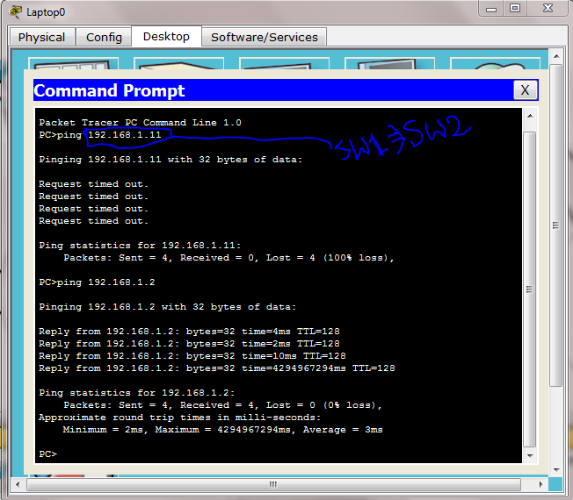

**Here In switch 1 under the host pc0 cant access switch 2 under the host pc4**

**===========================================================================**

Trouble Shooting Commands:

switch# show vlan brief